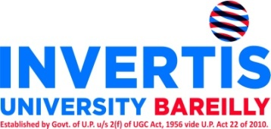
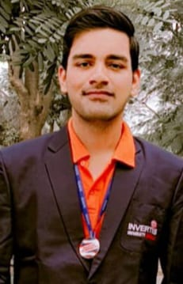

AARJOO VARSHNEY

LinkedIn | Mobile: 8445115747 | Email: aarjoov@gmail.com

CAREER OBJECTIVE

Passionate and results-oriented MCA student with a strong foundation in Java programming, web development, and database management systems. Seeking an opportunity as a Java Developer to apply my skills, contribute to dynamic projects, and grow in a fast-paced environment. Eager to learn new technologies and deliver high-quality solutions.

PROFESSIONAL QUALIFICATION

COURSE | BOARD/ UNIVERSITY | PERCENTAGE/CGPA | YEAR OF PASSING
MCA(Pursuing) | Invertis University | - | 2025

EDUCATIONAL QUALIFICATION

- Bachelor of Science (B.Sc.) from MJPRU.
- 12th from Up Board.
- 10th from Up Board.

SKILLS SUMMARY
- Proficient in programming languages such as Core Java, Python.
- Strong understanding of database management systems, including SQL
- Familiarity with web development technologies like HTML, CSS, and JavaScript
- Excellent problem-solving and analytical skills
- Effective communication and teamwork abilities.
- Skilled in data analysis techniques (Pandas, NumPy, Scikit-learn, Matplotlib, Seaborn) and tools as well as versed in Power BI.

PROJECTS
- Mudra Loan Fraud Prediction
- Built a machine learning model to predict loan frauds based on historical data.
- Conducted exploratory data analysis (EDA) and developed a structured pipeline for data preprocessing and feature engineering.
- Used algorithms like Logistic Regression and Random Forest, with hyperparameter tuning to optimize performance.
- Visualized insights using Matplotlib and Seaborn to enhance interpretability.

2. Cosmetic Store Management System (Java Mini Project)
- Developed a basic store management system using Core Java, MySQL, and JDBC.
- Implemented modules for product management and customer management.
- Designed simple login functionality with user role-based access.

INTERNSHIP EXPERIENCE
Data Analyst Intern
Cetpa Infotech, Noida
[June 2024 - July 2024]
- Analyzed and interpreted complex data sets to identify trends and insights that supported business decisions.
- Utilized tools such as Power BI and Tableau for data visualization and reporting, enhancing the clarity of findings for stakeholders.
- Collaborated with cross-functional teams to improve data collection processes and ensure data integrity.
- Assisted in preparing detailed reports and presentations based on data analysis, contributing to strategic planning initiatives.
Volunteer Experience
Discipline Coordinator
Invertis University, Bareilly
[Aug 2023] - [Jan 2024]
- Organized and led disciplinary activities for the MCA class, ensuring adherence to university policies and regulations.
- Facilitated communication between faculty and students regarding academic and disciplinary matters.
- Implemented strategies to promote a positive and cooperative learning environment within the class.

Certifications:
- Python (Basic)
  - Issued by HackerRank, March 2024
- Oracle Database 19c: PL/SQL
  - Issued by LinkedIn, February 2024
- Basics of Python
  - Issued by Infosys Springboard, January 2024
- Generative AI Fundamentals
  - Issued by Google Cloud Skills Boost, January 2024

LIGUISTIC PROFICIENCY English and Hindi

PERSONAL INFORMATION

Nationality Indian
Gender Male
Marital Status Single
Permanent Address Kaithal Gate Kaccha Katra Chandausi
Hobbies Cooking, Reading

Date: Monday, April 28, 2025
Place: Bareilly

