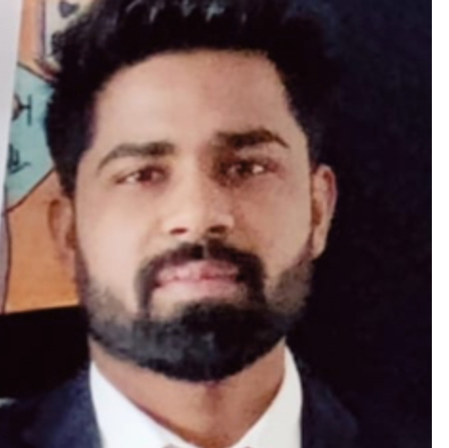



Professional Summary
Pankaj Tanwar
E-4 Ashok Vihar phase 2, Gurgaon, 122001 (IN)
pankajtanwar601@gmail.com
7082838658
I have one year of practical experience as a Process Associate at Neo Healthcare, along with prior exposure to one of India's largest pharmaceutical companies as a research intern.

Employment History
Process Associate, NEO HEALTHCARE. Gurgaon, Haryana Nov. 2023 - Present
Responsible for transaction processing, data entry, and insurance verification in operations within the outsourcing industry. Work in a dynamic, collaborative environment, handling tasks efficiently while bringing creative and thoughtful solutions to enhance processes and outcomes.
QC intern, Akums pharmaceuticals. Haridwar, Uttarakhand Jun. 2023 - Sep. 2023

"Gained hands-on experience in pharmaceutical operations, including documentation, SOPs, and laboratory instrument maintenance (HPLC, GC) during summer training."

Education
Chaudhary Bansilal university, Bhiwani, Haryana
Master of Science, Microbiology (Life sciences), May. 2024
Chaudhary Bansilal university, Bhiwani, Haryana

Skills
Performing secondary research

Handling Queries
Excel
Management
MS word
Data Analysis
Conduct research operation
Interpersonal skills

Languages
English
Hindi

Bachelor of Science, Chemistry zoology botany, Jun. 2021
Assam rifles public school, Shillong, Meghalaya
High School Diploma, Mar. 2016

Awards
Attended third hands on training on HPLC, GC, PCR Techniques, MDU Rohtak.
participated in workshop organized by Genetrix India, Gurgaon
Participated in workshop organized by Borosil,
Gold medallist in NTSE Science Olympiad

