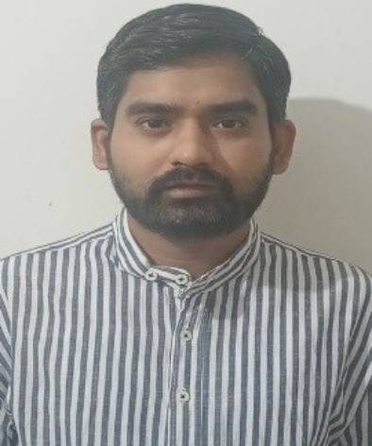
Susheel Kumar Jaiswal
Project Senior Analyst – AML/KYC | Compliance | Risk Assessment
📍 New Delhi, Delhi 110070
📞 +91 7982239489
✉ susheelj34@gmail.com
🔗 https://bold.pro/my/susheel-kumarjaiswal-250620090007/232r
PROFESSIONAL SUMMARY
Experienced professional with nearly 9 years in AML/KYC, compliance, and risk assessment at EY and Genpact. Expert in transaction monitoring, sanctions screening, due diligence, and forensic reviews. Skilled at mentoring teams, improving processes, and ensuring adherence to global AML regulations (BSA, USA Patriot Act, UAE guidelines).
CORE SKILLS
AML & KYC Compliance | Transaction Monitoring | Sanctions & PEP Screening | Risk Assessment & Due Diligence | Data Analytics | Auditing & Documentation | Customer Due Diligence (CDD) | SAR Filing & Case Investigation | MS Office Suite | Cash & Payment Operations | Compliance Knowledge | Team Management & Mentorship
PROFESSIONAL EXPERIENCE
Project Senior Analyst – Forensic (AML/KYC) – EY (Ernst & Young), Noida | Oct 2024 – May 2025
- • Reviewed sanctions screening alerts to identify and mitigate potential AML/FT risks.
- • Analyzed data to detect red flags and escalated critical issues to compliance leads.
- • Mentored junior analysts, enhancing knowledge of AML & KYC regulations.
- • Streamlined workflow processes, increasing team productivity and efficiency.
Senior Process Associate – Transaction Monitoring (AML/KYC) – Genpact, Gurugram | Aug 2022 – Jul 2024
- • Analyzed financial transactions, reviewing ~50 cases per week for suspicious activity.
- • Conducted due diligence on clients and third parties with 95%+ accuracy.
- • Filed SARs and ensured compliance with AML regulations (BSA, USA Patriot Act).
- • Utilized tools including LexisNexis, World-Check, and Bridger for AML screening.
- • Prepared due diligence commentary with complete client transaction analysis.
Senior Process Associate – Genpact, Gurugram | Jun 2021 – Jul 2022
- • Reviewed and validated customer documents for AML/KYC compliance.
- • Performed account maintenance, including updates to addresses, spouse names, and contact details.
- • Supervised process associates, boosting efficiency and accountability.
Senior Process Associate – Payment Operations (Lockbox) – Genpact, Gurugram | Jul 2018 – May 2021
- • Processed bills and checks, ensuring accurate payment operations under retail banking.
- • Prepared daily reports on volume completion for client transparency.
- • Trained junior associates in payment operations and compliance processes.
Process Associate – Brokerage Operations – Genpact, Gurugram | Jun 2016 – Jun 2018
- • Evaluated checks and processed details in live market systems (Wisdom, CEO).
- • Supported Wells Fargo Advisors Group in efficient check deposit reviews.
- • Managed multiple tasks under strict deadlines, ensuring accuracy and compliance.
EDUCATION
Master of Arts (Political Science) – Bundelkhand University – Jhansi (2013)
Bachelor of Arts – Bundelkhand University – Jhansi (2011)
Class XII – U.P. Board – T.I.C Rajapur (2005)
Class X – U.P. Board – T.I.C Rajapur (2003)
CERTIFICATIONS
• Lean Certified
• Boot Camp
LANGUAGES
English, Hindi

Additional Information
- • Person with Disability (PWD Category: Low Vision)

