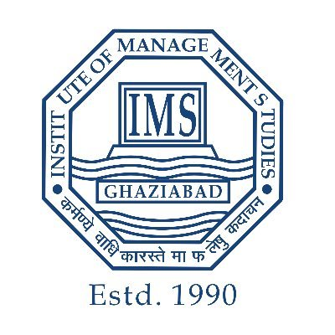

Anushka Bhadoria
a2024pgdm4597@imsgzb.ac.in | +91 9329426108

https://www.linkedin.com/in/anushka-bhadoria-98b76b

EDUCATION
Year | Degree | Institute | % / CGPA
2024-26 | PGDM (Pursuing) | Institute Of Management Studies, Ghaziabad | 7.74
2021-2024 | B.Com (H) | ITM University, Gwalior | 6.76
2021 | 12th | St. Paul’s School, Gwalior. | 70%
2019 | 10th | St. Aloysius Senior Secondary School, Jabalpur. | 63.5%
ACADEMIC ACHIEVEMENTS
Certifications | - Global Immersion Program at Dubai at IMS Ghaziabad. (2025)  - Financial Management certification.(2024)  - KPMG Financial Modelling and Valuation.  - Certification of Achievement for securing 1 position in marketing plan: Digital Escape room competition at IMS Ghaziabad.  - Certification of Achievement for most creative campaign at IMS Ghaziabad.
Competitive Exams | CMAT-2024
WORK EXPERIENCE / INTERNSHIP PROJECTS
Name of company  Duration | Summer Internship at KPMG (15 May to 15 July 2025).  Role – Finance Intern.  Responsibility :-  - Financial Data Analysis of the companies.  - Worked on Financial Models: DCF, CAPM, LBO & Debt Revolver.  - Comparative Ratio Analysis of the Industrial Products sector.
POSITIONS OF RESPONSIBILITY
Responsibility | - Member of Finnacle – The Finance club.  - Member of Markwiz – The Marketing club.  - Member of Design & Décor at Melange.
CO-CURRICULAR ACTIVITIES
Activity  Technical skills | - Part of the promotional team of the inter-college fest ‘Melange’.  - Event organizer and coordinator.  - Part of workshops, seminars & panel discussion.  - Led group dance performances as part of cultural activities.
Activity  Technical skills | - MS- Office – Excel, PowerPoint, Word.  - Canva.  - Analytical skills.

