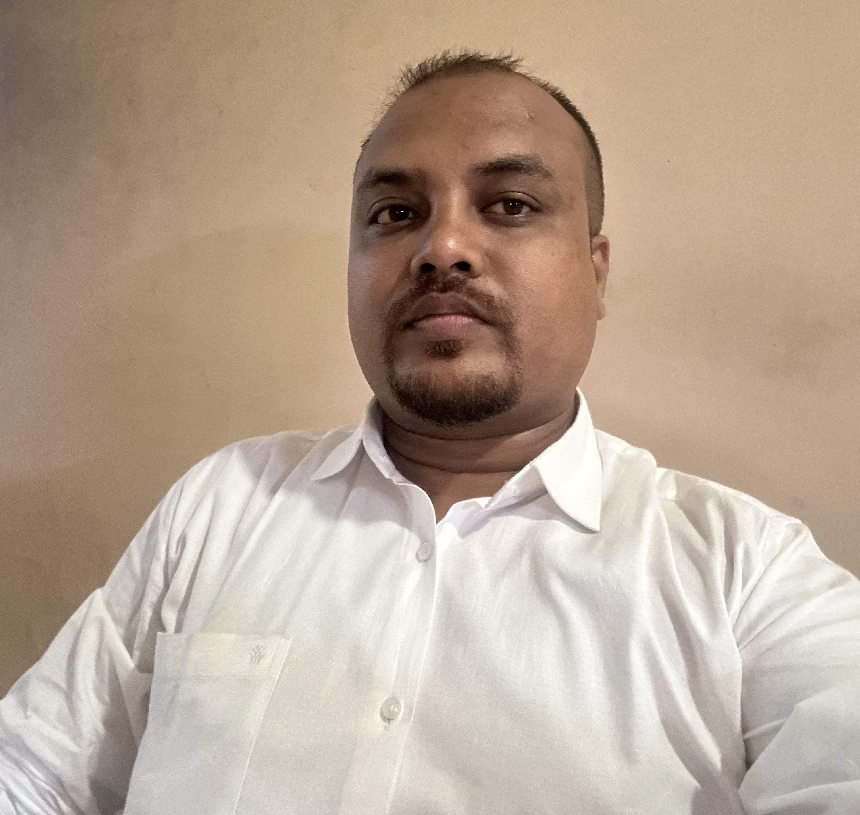
RESUME

MONUJ KUMAR BORA

Dergaon, Bhabanipur ward no -3
P.O/ P.S : Dergaon, Dist : Golaghat,(ASSAM)
Pin : 785614

CONTACT NO - 7002555418

Email-monujbora1992@gmail.com

CAREER OBJECTIVE:

To be a successful professional in a respected company and to achieve the objectives of the company with Honesty and Fairness and to continuously upgrade my knowledge and skills.

EDUCATIONAL QUALIFICATION:

S. NO | EXAM PASSED | BOARD/ UNIVERSITY | YEAR OF PASSING
1 | CLASS 10 | SEBA | 2008
2 | CLASS 12 (SCIENCE) | HSC | 2010
3 | B. Sc | PRAGJYOTISH COLLEGE | 2013

PROFESSIONAL PROFILE:

WORKING EXPERIENCE -

- 0ne year working experience in CIPLA as a TM at H.Q.-Dibrugarh , & covering area, are jorhat ,Sivsagar, Golaghat , Dimapur. From 3/02/2014 to 15/03/2015

- Five years working experience in ALEMBIC as a PMR at H.Q.- Jorhat & covering area, are Sivsagar, Golaghat , Dimapur Kohima & Mokokchung . From 15/03/ 2015 to 16/07/2018 &
I got promote as a ASM ALEMBIC from16/07/2018 to 2/02/2020 & covering area, are DIMAPUR , DIBRUGARH & TEJPUR

- After that I have joined LOTUS SURGICALS PVT LTD as a DM at H.Q – JORHAT & covering area are – DIBRUGARH , NORTH LAKHIMPUR , ARUNACHAL PRADESH , NAGALAND .From 2/02/2020 to 14/07/2024
- After lotus Surgicals I have joined Qubix Medicare Pvt Ltd

- Total working experience 11 years

LANGUAGE KNOWN : can read, write. & speak
Assamese, English, Hindi

HOBBY : PLYAING GAME, OUTTING , READING
NEWSPAPER.

PERSONAL INFORMATION :

Father’s Name - LOKHIRAM BORA
Date of birth - 10/02/ 1992
Nationality - INDIAN
Gender - MALE
Marital status - Married

DECLARATION

I hereby declare that above information and details are true and correct to the best of my knowledge have been concealed or distorted
DATE: 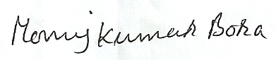
SIGNATURE
(Monuj Kumar Bora)
PLACE : Jorhat

