
Applied position and location | Production (Sr.executive)
Candidate Name | Bhanuprakash varma
Qualification | B.Pharma
Current / previous Organization | Caplin steriles limited
Current Designation | Production officer
Overall Exp | 3+ yrs
Current CTC (LPA) | 3.6 LPA
Expected CTC (LPA) | 20-30% hike
Notice Period | 45 days
Location | Tirupati

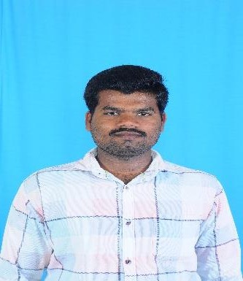
BHANUPRAKASH VARMA

PRESENT ADDRESS
Near MPDO Office, Sathyavedu (P&M), Tirupati Dist. AP 517588

PERSONAL DATA
Father’s Name : J Purushotham
Mother’s Name: Chilakamma

Date of Birth : 25/12/2000 Blood Group : B+ve Gender : Male
Nationality : Indian
Marital Status : Unmarried
Languages Known: English, Tamil, Telugu (RWS)

PERSONAL STRENGTH
- Punctuality
- Adaptability
- Self-motivation

CAREER OBJECTIVE:
To be Professionally associated with an esteemed organization which provides me a challenging career that assists in further enhancing my skills and achieving the goals of the organization.

EDUCATION:

B.PHARMACY: 2018-2022 Seshachala College of Pharmacy, Puttur Affiliated to JNTUA. Percentage: 78%

Intermediate : 2016 - 2018
APSWRS School and Jr. College, Ramakuppam, Chittoor Dist. AP.
Percentage:79%

SSC :2015 – 2016

MJPAPBCWRS (Boys) Sadam, Chittoor Dist. AP.
Percentage:77% EXPERIENCE:
- I am working at Caplin steriles limited as a Production officer since May 2023.I have the ability to handle below mentioned Execution activities.
- I have the ability to handle my activities independently and as a team for the growth of the organization.

RESPONSIBILITIES HANDLED IN PRODUCTION:

  - Execution of Batches,
    - Filling activity, In process checks.
    - Dispensing of primary and secondary packing materials and consumables
    - Monitoring of terminal Sterilizer during sterilization.
  - Vial washing machine and dehydrogenating tunnel qualification activity.
  - Documentation, review and maintenance of BMR and logbooks.
  - Planning and monitoring of vial washing activities
  - Planning and monitoring of autoclave load operations,
  - Autoclave load patterns preparation,

  - Maintaining track record for garments, autoclaves, filters.

  - Monitoring of Terminal sterilizer during sterilization,

  - Segregation of each lot after Terminal sterilization, to avoid batch mix-ups

  - Coordination with Technician for timely completion of batch activities,

  - Preparation and Review of SOP′s, and protocols

  - Handling and planning of shift activities

  - To follow the cGMP

INSTRUMENTS/ SYSTEMS HANDLED:
  - Vial washing machine and Depyrogenating tunnel
- Rotatory vial washing machine and depyrogenating (KLELZOID)
- Linear vial washing machine and depyrogenating (NKP)
- Vial washing machine and depyrogenating tunnel (SYNTOGON)
  - Steam sterilizer (Make: Machine fabric, Metal chem),

  - Filter integrity machine (make:Millipore),

  - Terminal sterilizer (make: Metal chem),
  - Vision based counting machine,

DECLARATION:
I hereby declare that the information furnished above is true to the best of my knowledge.

Date: J BHANUPRAKASH VARMA
Place:

