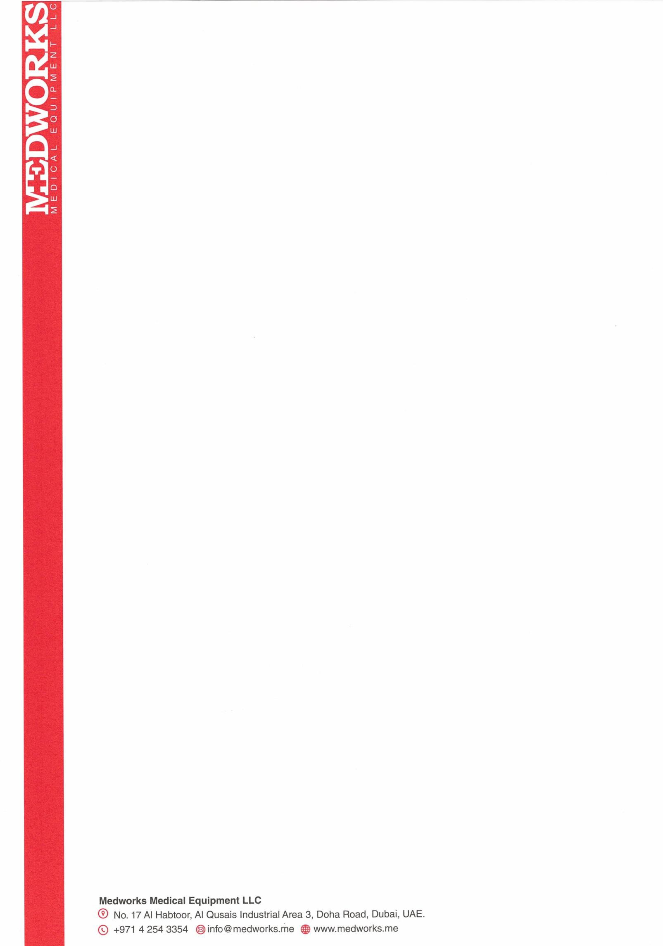
Dear Mr Rupesh Bishwambhar Mishra,

Thank you for your interest in Medworks India Pvt Ltd.

Based on your resume and the interview you had with us, we are pleased to make you an offer of employment as a Product Manager at Medworks India Pvt Ltd for Mumbai and Surat region to be based in Mumbai on a fixed term contract, for the remuneration as offered and agreed by us (details given below). The Management reserves the right to bifurcate or merge the allowances in basic salary.
The Net Salary (In Hand) offered to you will be Rs 82500 only per month Apart from salary you will be eligible for a group Medical Insurance cover and PF. You will be entitled to an incentive of 1.2 % of the achieved sales target. You will be eligible for a Daily Allowance of INR 600/ Day for local and 900 / Day for outstation apart from Stay.

This employment offer is subject to:
- The information provided by you in your resume and interviews are correct and valid.

- This offer letter is valid for 4 days from issuance and your expected DOJ will be August 10th 2025. If you do not join us by the stipulated date, this offer is deemed invalid. Your formal appointment letter will be issued at the time of your joining, subject to receipt of various mandatory documents, as per list given below.

  - Aadhar card for proof of identity, proof date of birth and proof of address.
  - Educational certificates
  - ESI declaration in Form 1, PF nomination in Form 2 and Gratuity Nomination in “Form F”
  - PAN Card, Bank A/C details with proof
  - Two passport size photographs
  - Proof of your last drawn salary
Please note that any claims based on alleged verbal promises by any authority in the organization are not a part of this letter and will not be entertained in future.
We look forward for you to join our organization at the earliest.

With warm regards,

Medworks India Pvt Ltd

Mr Arun Keshavan Mr Rupesh Mishra Director

Authorized Signatory Signature
Date: 05/08/25 Date: 05/08/25

Medworks India Private Limited
A-02, Amit Nagar CHS Ltd, Yari Road, Andheri West OPP DCB Bank,
Mumbai, Mumbai City, Maharashtra, India, 400061 Emai: info@medworks.in

