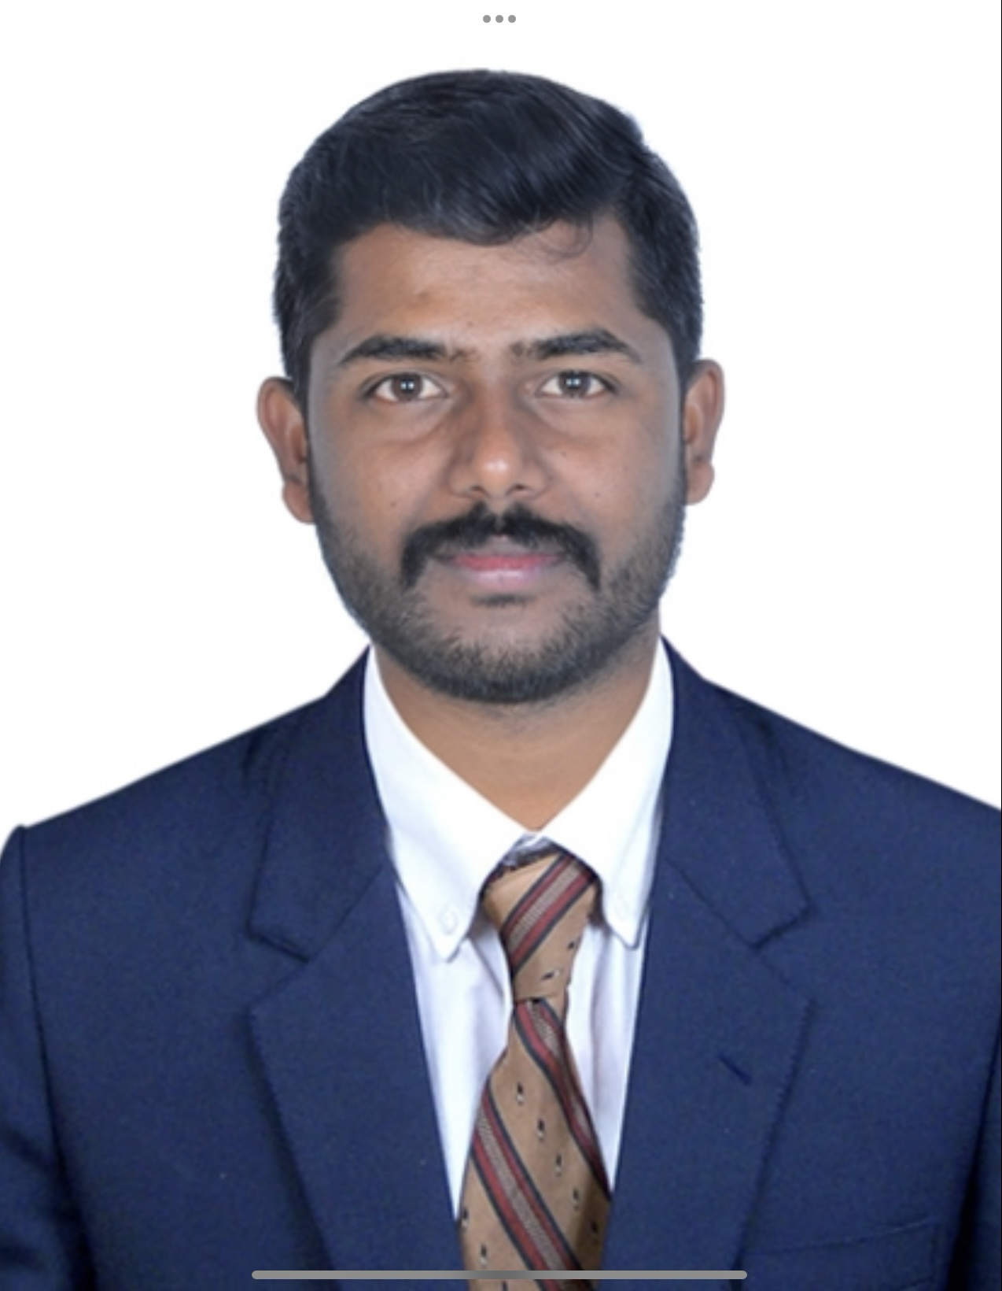 | A VARADARAJ
   | Hosakerehalli Bangalore 560085
   | 9035173733
   | Arvraj2736@gmail.com

Summary | Looking forward for opportunities in the field of Sales, Marketing, Business development,Key Account Management, Medical devices, Institutional sales & Corporate sales in a reputable Organisation to expand my learning & Cross functional Skills while a significant Contribution in Company's Success.

Experience | Therapy specialist , 11/2020 - Current  Viatris Company (Mylan Pharmaceuticals), Bangalore , India  - NCD Care  - Accomplishments include:  - Hit and exceeded sales KPI by 15% for Q1 and Q2 April and May by 13% in 2024.  - Achieved Non sales KPI continuously for more 1 year.  - Sent 200+ Rep triggered email (RTE) on a Monthly basis.  - Certificate of Appreciation (Viatris Digital Champions Club) in sept 2023.  Territory executive , 08/2018 - 11/2020  Pfizer ltd, Bangalore , India  - Chronic care  - Accomplishments include:  - number one ranking in sales Southern region-2019.  - All India number one ranking in sales-2020.  - Qualified for international trip (Malaysia).  - Sales Contest winner, New Products for 3rd and 4th Quarter 2022.  Territory Business Manager, 03/2016 - 08/2018  Sun pharmaceuticals Bangalore, India  - General segment  - Accomplishments include:  - Achieved more than 100% on newly launched product (sonata)  Medical Representative , 12/2013 - 03/2016  Emcure pharmaceuticals , Bangalore , India  - General Segment  - Accomplishments include:  - Top 5% in region for total sales in 2015.  - Three years continue budget Achievements

Skills | ..
  - Proficient Communication Skills  - Leadership quality  - knowledge of basic and advance pharmacolog  - Conversant presentation skills | - Strong problem-solving skills  - Good attention to detail  - Strong scientific knowledge  - self motivated, ”do-er”, willing to work hands-on.

Education | B.sc (P.M.Cs)Kuvempu University,Karnataka , 2011

Software | - Ms - Office, Excel, Internet, Ms Outlook and Photoshop.

Languages | - English, Hindi, Tamil,Telugu, Kannada.

Area of interest | - pharma sales.  - medical devices.

Hobbies | - Motivational book, cooking, chess and badminton

Personal details | - Father's name - Arumugam .S  - Date of birth – 10/07 /1988  - Gender - Male  - Martial status – Married  - Nationality - Indian  - Permanent address – Hiriyur Taluke, chitradurga Dist , Karnataka state

Declaration | - I hearby declare that the above information furnished is true to the best of my knowledge and belief.

