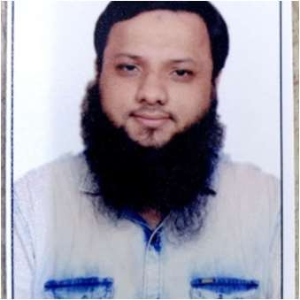
Mohammed Zeeshan Sayyed
 Mira Road East, Thane 401107
 +91 - 7977320910

zeeshan568@gmail.com

2021-07 – 2025-04

2020-02 - 2021-03
Enthusiastic and motivated individual passionate about customer service. Team player works well both independently and within team settings to achieve goals. Skilled communicator and problem solver committed to creating positive customer experiences. As professional with high standards and focus on results, adept at managing customer interactions and providing exceptional service.
Known for reliability and adaptability in dynamic environments, ensuring seamless team collaboration and positive outcomes. Proficient in conflict resolution and communication, valued for positive attitude and customer-first approach.



Work history

Customer Service Associate
Accenture Solutions Pvt Ltd, Mumbai
- Worked as a Customer Service Associate in the Web Messaging Chat Department, assisting American customers of Verizon. Responsibilities include providing support for device troubleshooting, device upgrades, international travel plans, monthly payments, device credits, billing inquiries, and roadside assistance.
- Effectively handled customer complaints, ensuring professional resolution, satisfactory outcomes, and positive feedback.
- Maintained a high level of product knowledge, delivering accurate information to customers.
- Recognized as the Best Agent for the period from September 2021 to August 2022.

Customer Relationship Advisor
Tech Mahindra Business Services Ltd, Mumbai
- Worked as a Customer Relationship Advisor in the UK Postpay process with the following responsibilities:
- Handled customer queries in a web chat process for UK Postpay, providing support to Three Mobile Customers.
- Managed dual customer interactions simultaneously via chat, maintaining an average handling time of 480 seconds (8 minutes) per customer.
- Assisted customers with issues related to their mobile handsets, internet
connectivity, and Wi-Fi routers.




2013-05 - 2019-12

2011-04 - 2012-12

2008-07 - 2010-02

1996-06 - 2008-03
- Resolved billing disputes, assisted with u[dating personal account details, and provided payment extensions based on system guidelines.
- Advised customers on making live payments using their cards through secure systems

Owner
MZee Computers, Mumbai
- Owned and managed MZee Computers, a computer hardware and networking shop, from May 2013 to December 2019.
- Provided services such as hardware sales, repairs, and networking solutions, ensuring excellent customers satisfaction and technical support.

Education

Diploma: Computer Hardware & Networking Institute
Jetking Computer Hardware & Networking Institute - Mumbai, India

HSC: Commerce
Maharashtra State Board - Mumbai, India

SSC: Schooling
Maharashtra State Board - Mumbai, India

Chat skills
- Accuracy with speed
- Handling four customers at a time
- Resolving multiple concerns for all customers
- Managing all four customers at a time
- Waiving late fees & financial charges
- Confidentiality
- Overtime as well as hitting booster (incentives)
- Work with team
- Help teams with tips and tricks
- Assisting & training OJTs
- Work on new updates regarding procedure
- Analyzing information
- Flexibility with shifts
- Results driven



Personal Details
Father Name: Gulam Jilani Sayyed
Date of Birth: 18th May 1991 Nationality: Indian
Marital Status: Married Gender: Male

Languages
English Hindi Marathi Urdu
Hobbies
  - Cricket: Active participant in cricket, showcasing teamwork, leadership, and strategic thinking.
  - Swimming: Pursue swimming to maintain physical fitness and enhance focus and discipline.
  - Bike Riding: Passionate about bike riding, fostering a sense of adventure and resilience.

.

