Brown | SAVITRIBAI PHULE PUNE UNIVERSITY  (formerly University of rune)  GANESHKIIIND PUNIC 411 007  STATEMENT OF MARKS / GRADES FOR B. Com. (2013) EXAM. -- APRIL 2020  SEAT NO. 24491 CENTRE OO i PERM REG. NO. : 1201932365 NAME ADH IKARI KOMAI- HIRASINGH MOTHER • BHAVANA  COLLEGE  0937 GMT. KASHIBAI NAVAI-E COLLEGE OF COMMERCE PONE
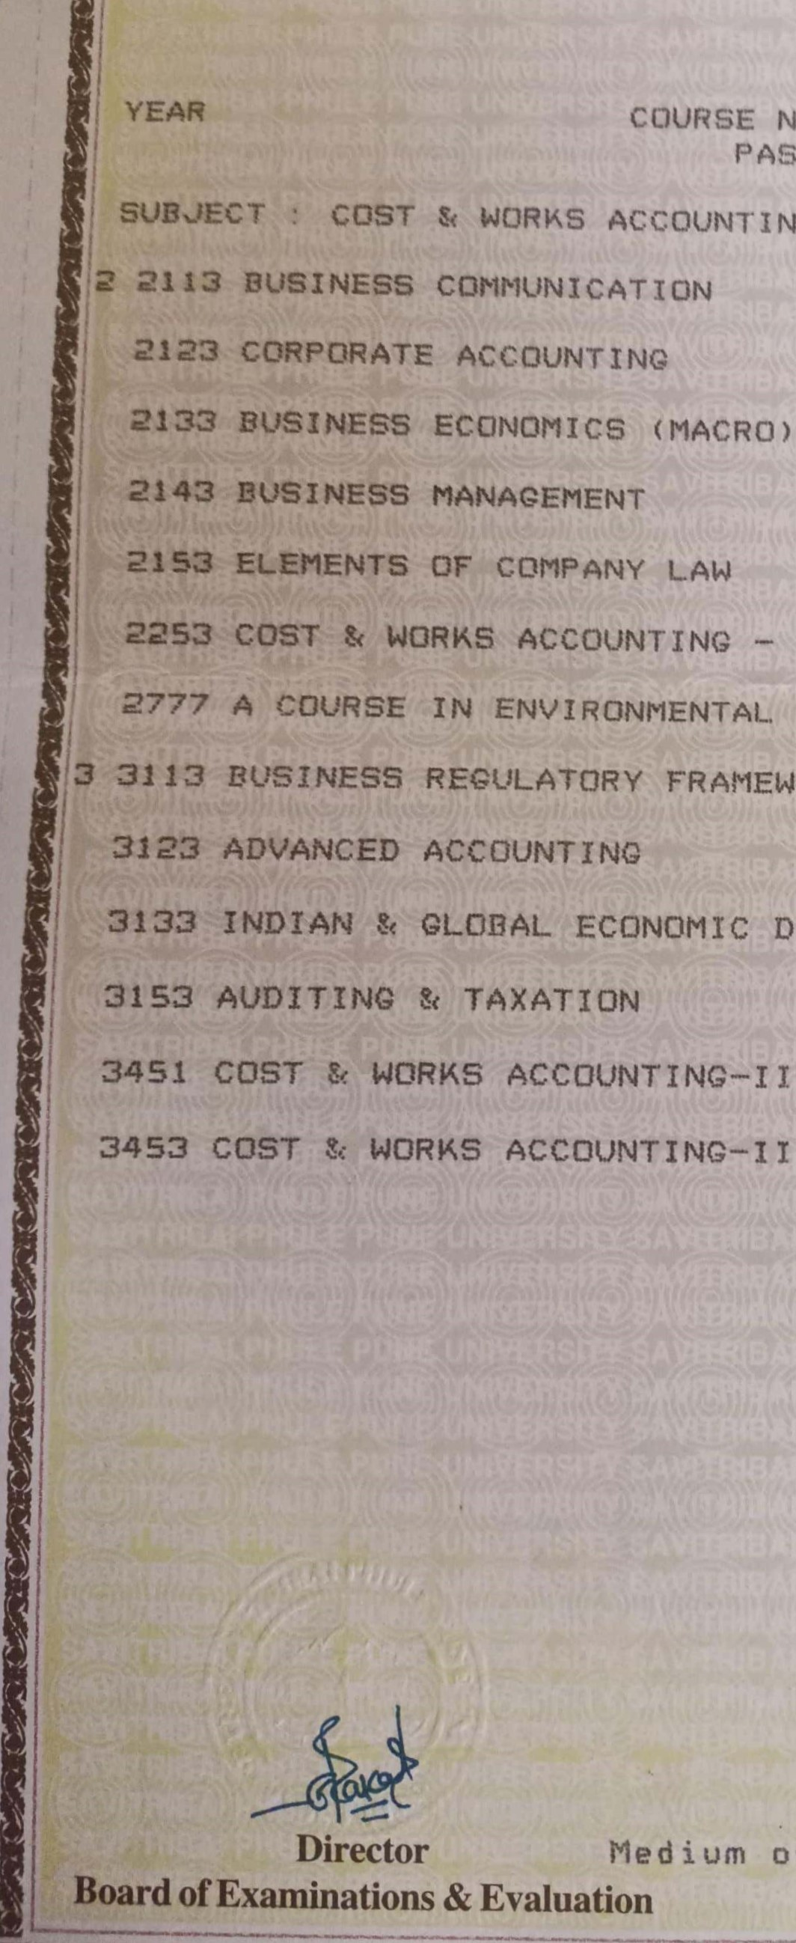
MARKS OBTAINED
NAME
PASSING/OWT
8/20
ACCOUNTING
1B
16
AWARENESS
FRAMEWORK
DEVELOPMENT
15
ACCOUNTING-111
19
GRAND
TOTAL
(OUT
OF
instruction:
English
DATE
:
12
NOV
2020'
32/80 40/ 100

2123 CORPORATE ACCOUNTING
21 aa BUSINESS ECONOMICS (MACRO)

2143 BUSINESS MANAGEMENT

21 sa ELEMENTS OF COMPANY LAW
2253
2777
13 32 la

3123 ADVANCED ACCOUNT INC
3153 AUDITING TAXATION
3451
3453
TEX.
17
10
15

GRADE
14
16
17
RESULT

UEX. TOTAL
6B se
40 50
46 61
44 56
48 63
64 * 7B

as
34 64
56
41 * 77
1200) 739
FIRST CLASS

