Data Quality Analyst
Hamsaveni

hamsaveni@optisolbusiness.com
Hamsaveni M
+91 9566217302

SUMMARY STATEMENT
Dynamic and detail-driven Data Quality Tester with eight years of proven success in making enterprise data trustworthy, accurate, and analytics-ready. Expert at uncovering hidden data issues, validating complex ETL/ELT pipelines, and building test strategies that strengthen data reliability end-to-end. A strong partner to data engineering and BI teams, consistently improving data flows, eliminating defects early, and elevating the overall data quality landscape. Recognized for a proactive mindset, crisp documentation, and an unwavering commitment to delivering clean, consistent, high-confidence data that drives smarter decisions.
EXPERIENCE
Data Quality Analyst / JAN 2017 – Dec 2023
Citi Bank / Citi Rewards Program

- Led end-to-end data quality validation for a large-scale fintech rewards platform managing millions of customer reward transactions per month.
- Conducted detailed verification of rewards accrual, redemption, cashback, and points-expiry logic by validating complex source-to-target ETL mappings and business rules.
- Performed extensive SQL-driven reconciliation of customer transactions, merchant data, loyalty rules, and reward disbursements to ensure 100% accuracy across data pipelines.
- Detected and resolved high-impact data discrepancies involving mismatched points, incorrect reward calculations, and delayed postings, improving data reliability by 35%.
- Collaborated with data engineering and product teams to enhance transformation logic and streamline ingestion flows for rewards-related datasets.
- Developed reusable automation scripts for validating reward logic scenarios and transactional data, reducing manual testing effort by 45%.
- Ensured compliance with financial and audit standards by maintaining comprehensive documentation covering test strategy, test cases, defect logs, and validation reports.
- Played a key role in UAT cycles by validating new reward features, partner integrations, and promotional campaigns prior to production release.

CERTIFICATION
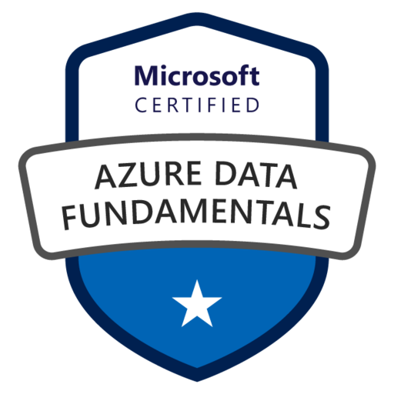

TECHNICAL SKILLS
Databases:
MYSQL, MSSQL, DB2, Snowflake
ETL/ELT Tools:
DBT, AWS Glue

Cloud Computing:
AWS, Azure

Data Storage Tools:
Azure Blob storage, AWS S3

Languages:
Python, SQL

Data Frameworks:
PySpark, Pandas

CI/CD:
Azure DevOps
Project Managment Tools: JIRA, Azure, DevOps

Education
Data Quality Analyst / JAN 2023 – Dec 2026
Citi Bank / Citi Bank to Axis Bank Card Migration (Mainframe Systems)

- Led data quality validation for the large-scale migration of Citi Bank card customer data into Axis Bank’s mainframe-based core banking environment following the acquisition.
- Performed detailed validation of customer master records, card account details, credit limits, balances, and card ownership mappings across mainframe datasets (DB2, VSAM) to ensure accurate end-to-end migration.
- Executed source-to-target reconciliation by comparing Citi’s legacy mainframe files with Axis Bank’s standardized schemas, identifying mismatches in account attributes, statuses, and customer relationships.
- Validated batch job outputs, COBOL program transformations, and nightly load cycles to ensure the correct conversion of card lifecycle events such as billing, payments, charges, rewards, and delinquency statuses.
- Identified and resolved high-impact defects including missing customer attributes, incorrect card-to-owner linkages, and misaligned credit limits, resulting in a 30% reduction in migration-related data inconsistencies.
- Collaborated closely with mainframe developers, data conversion teams, and functional SMEs to refine transformation logic and correct discrepancies across staging, conversion, and final load layers.
- Developed JCL-based validation scripts and DB2 SQL queries to automate repetitive data checks, reducing manual verification time by 40%.
- Conducted UAT and migration rehearsal cycles validating key card operations—activation, billing, statement generation, and fee calculations—within Axis Bank’s mainframe environment.
- Ensured compliance with regulatory and audit requirements by producing detailed test cases, conversion validation reports, and defect audit logs for all migration phases.
- Supported post-migration production checks by validating initial transaction cycles, customer updates, and card ownership transfers, ensuring a smooth transition for all migrated customers.
- Collaborated with data engineering and product teams to enhance transformation logic and streamline ingestion flows for rewards-related datasets.
- Developed reusable automation scripts for validating reward logic scenarios and transactional data, reducing manual testing effort by 45%.
- Ensured compliance with financial and audit standards by maintaining comprehensive documentation covering test strategy, test cases, defect logs, and validation reports.
- Played a key role in UAT cycles by validating new reward features, partner integrations, and promotional campaigns prior to production release.
MBA – System management Madras University, Chennai

BSC - CS
Jain college, Chennai
EDUCATION

